Demo Video Recording Guide
- You need to record a presentation video (no more than 5 minutes) explaining your participation and demonstrating that your lab is working.
- For example, in group of three students, you can consider 1 minute for each student and 2 minutes for your demo.
- The goal of the participation part is to talk about your contribution in the lab. And the goal of the demo part is to show that your lab works in your environment.
- You can use Zoom or any video recording tool like OBS Studio. See below.
- After recording the video, upload it to a server (e.g., Google Drive or Youtube) and share the link with your lab report. Make sure the server you choose shows the exact time of your uploaded video file.

Extra requirements for integrity
- Emphasis should be on the content and not the style of delivery.
- Record in fullscreen and keep the same resolution as your screen display so that your system clock is VISIBLE. When using Zoom as your recording tool, one person can share the screen while others speak; do not stop screen sharing.
- Do not edit the recorded video using video editing software such as Adobe Premiere.
- No need to speak about the details of your code in the video as long as you clearly show that your code is working. But make sure your report includes a comprehensive description of the code.
- The recording should be STRICTLY your own. All submissions are monitored for similarities.

How to record using Zoom
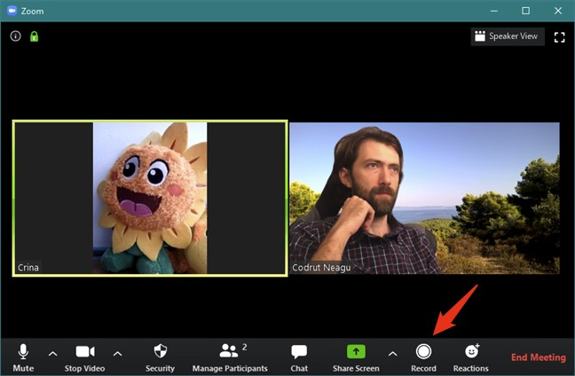
- Zoom is one of the easiest ways to record a video. After starting your meeting, start recording by pressing the Record button at the bottom.

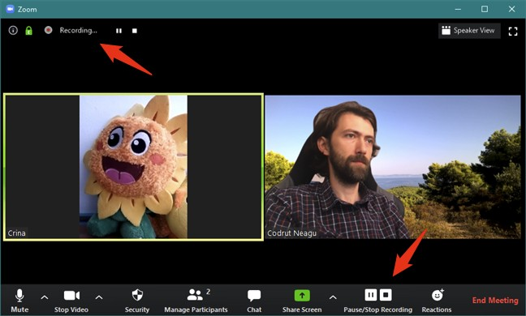
If you have cloud recording enabled, a pop-up will appear asking where you want to record: Record on this Computer or Record to the Cloud. You’ll know recording has begun when you see a redlight that says “Recording.”

- You can pause/resume/stop recordingOnce you are done with the recording you can press “Stop Recording” and end the meeting.

- You can view the recording location by going to the Recording tab in your Zoom Preferences(Mac)/Settings (Windows).
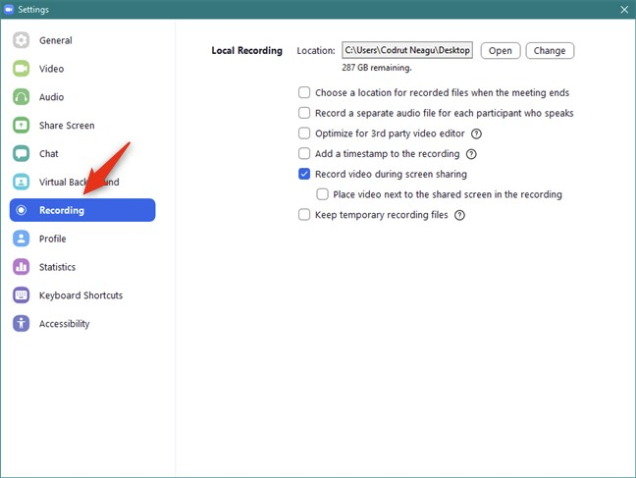
You should be able to see your recordings once you navigate to the above directory. Here’s a blog you can refer to for more details on recording using zoom:
https://www.digitalcitizen.life/record-zoom-meeting/

How to record using OBS Studio

You can use any other recording software. Here is just an example of OBS Studio.

Download & Install

Download from: https://obsproject.com/, and follow the installation guide. Easy like this.

Set video resolution

As previously said, keep fullscreen and system resolution. To set this, go menu bar --> File
--> Settings --> Video tab on the left.

Please change the “Base (Canvas) Resolution” and “Output (Scaled) Resolution” to your
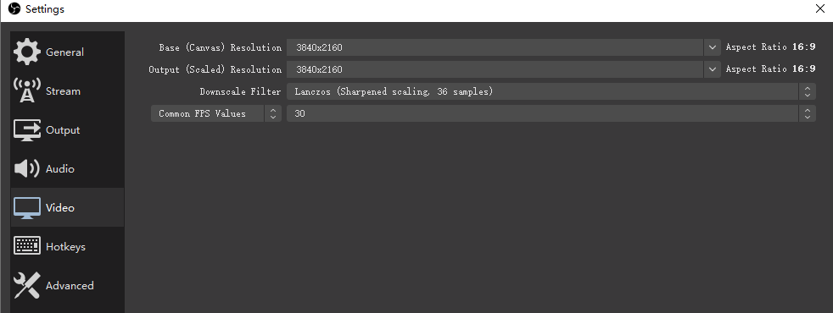
system resolution. Keep all other settings as the same as in Figure 1.
Figure 1 Set video resolution.

Set output/encoding parameters

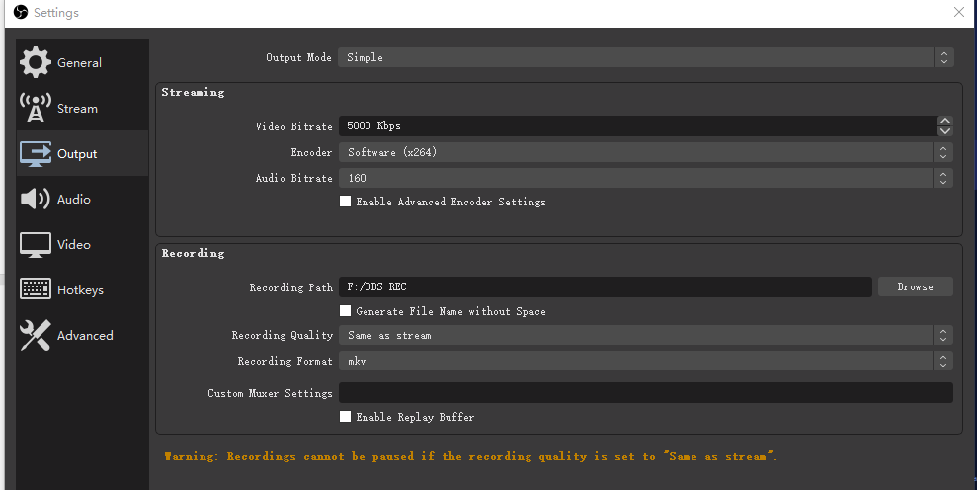
Fortunately, OBS Studio provides a simple mode to require us to set only a few key parameters to control the recording quality as well as file size. Just change the “Recording Path” to yours and keep all others the same as in Figure 2
Figure 2 Set output/encoding parameters.

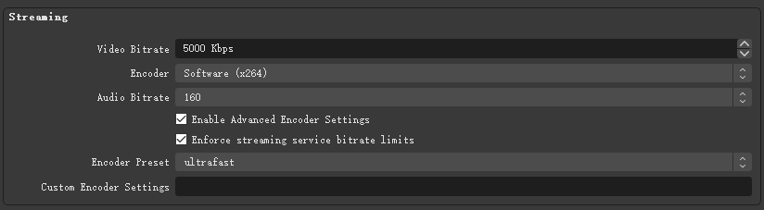
If you find your computer is slowed down too much while recording, check “Enable Advanced Encoder Settings” and select “ultrafast” for “Encoder Preset”, as shown in Figure 3
Figure 3 Decrease CPU usage.
Click “OK” to finish setting

Adjust canvas
In the main window you can find OBS Studio is capturing your monitor and displaying it in the middle. If not, jump to section “Create scene” and come back later.

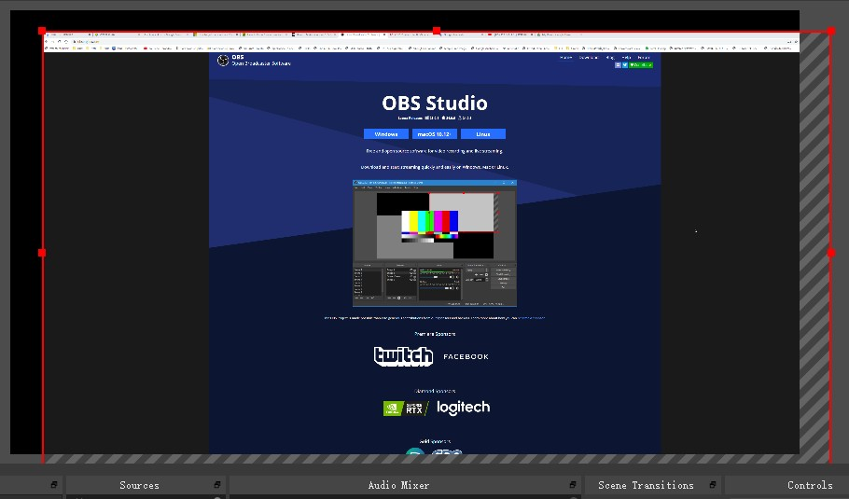
By default, it should display the full screen here. If not, you can click on the display area to focus on the captured screen so that you can resize and drag to let it exactly fit the capturing area (with black background) as shown in Figure 4.
Figure 4 Adjust canvas.

Start & Stop Recording

Click “Start Recording” in the main window. Click it again to stop. Then you can find a video file in the path you just set previously.

